 

**Placement Empowerment Program**

**Cloud Computing and DevOps Centre**

**Implement Auto-scaling in the Cloud**

**“*Set up an auto-scaling group for your cloud VMs to handle variable workloads..*”**

Name: **DHARSHINI P** DEPARTMENT: **IT**



**Introduction**

In cloud computing, applications often experience varying levels of demand. To ensure optimal performance and cost-efficiency, auto-scaling dynamically adjusts the number of virtual machines (VMs) in response to workload fluctuations. By automatically scaling resources up or down, businesses can maintain availability while optimizing costs.

**Overview**

Auto-scaling is a cloud feature that automatically increases or decreases compute resources based on predefined policies, metrics, or conditions. It ensures that applications handle peak traffic without performance degradation and scale down during off-peak times to save costs. Auto-scaling is commonly used in cloud platforms like AWS, Azure, and Google Cloud

**Objective**

**The primary objectives of this POC are:**

* Set up an auto-scaling group to manage cloud VMs efficiently.
* Ensure seamless performance during variable workloads.
* Reduce unnecessary costs by dynamically scaling resources.
* Improve system reliability and availability.

**Important Concepts**

* **Cost Efficiency:** Prevents over-provisioning by adding or removing VMs as needed.
* **Performance Optimization:** Ensures that applications can handle traffic spikes without performance degradation.
* **High Availability:** Distributes traffic efficiently and prevents downtime by maintaining necessary resources.
* **Automation:** Reduces manual intervention, making resource management more efficient

**Steps to Implement Auto-Scaling**

**Step 1:**

**Set Up Virtual Machines (VMs)**

* Choose a cloud provider (AWS, Azure, Google Cloud, OpenStack, etc.).
* Deploy a base VM instance with required configurations.

**Step 2:**

**Create an Auto-Scaling Group**

* Define the minimum, maximum, and desired number of instances.
* Configure instance types and launch templates.

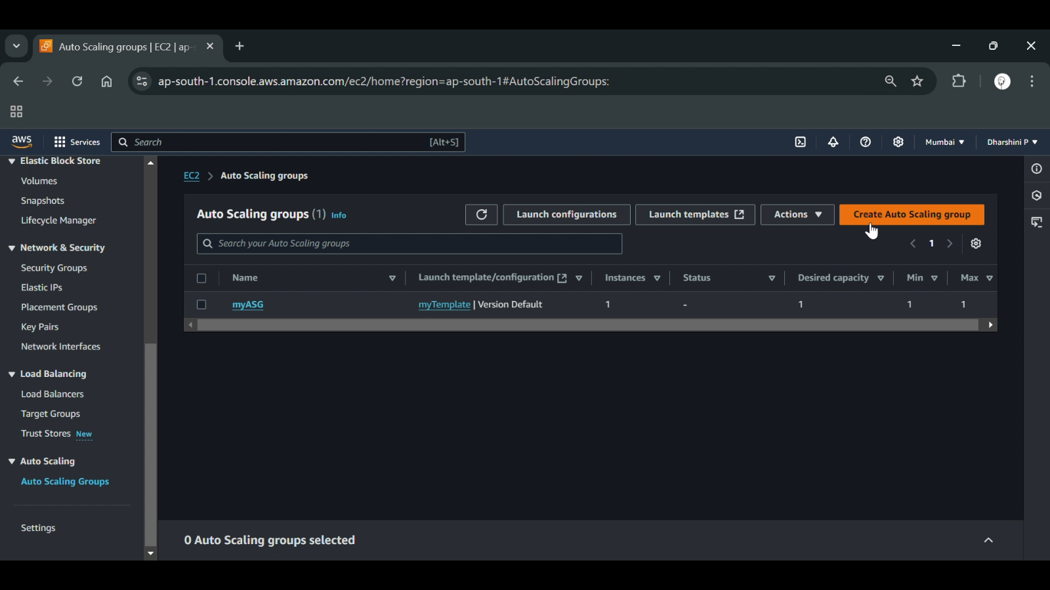

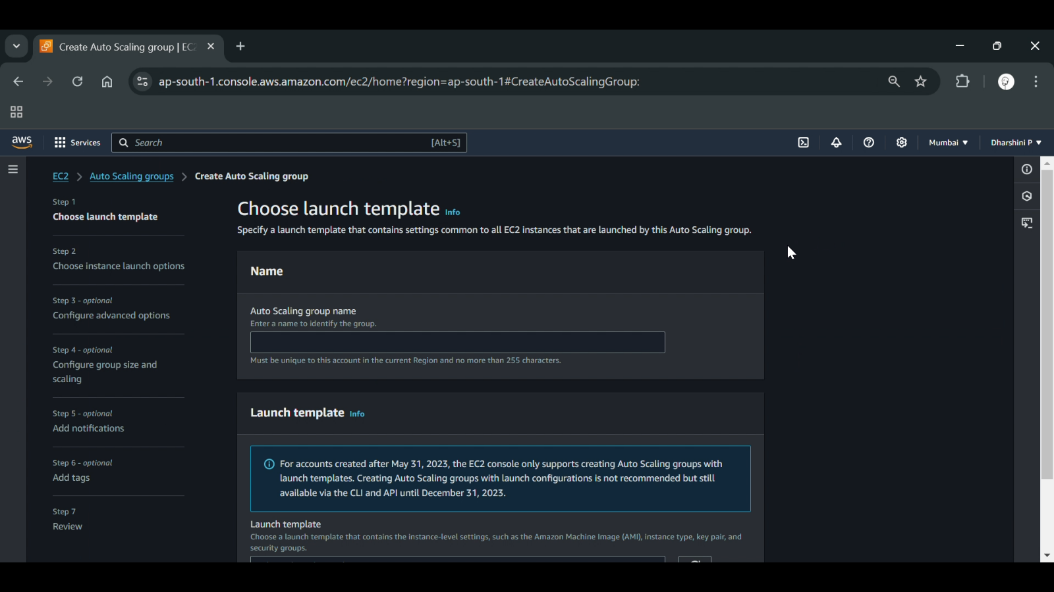

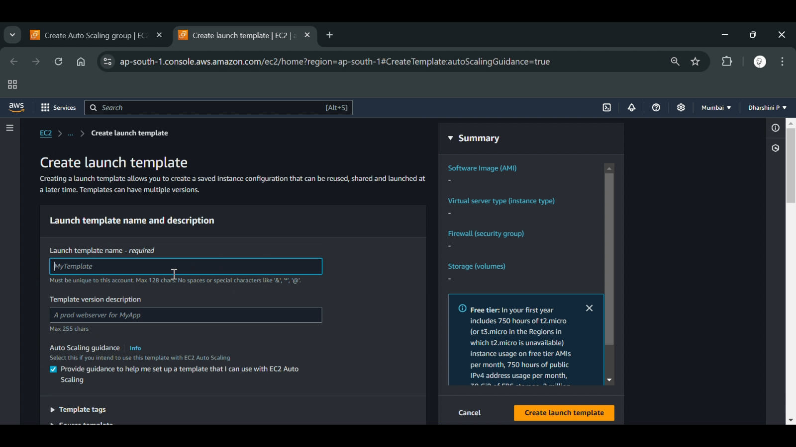

**Step 3:**

**Configure Scaling Policies**

* **Reactive Scaling:** Scale based on CPU, memory, or network utilization metrics.
* **Predictive Scaling:** Use machine learning or past data trends to anticipate demand.

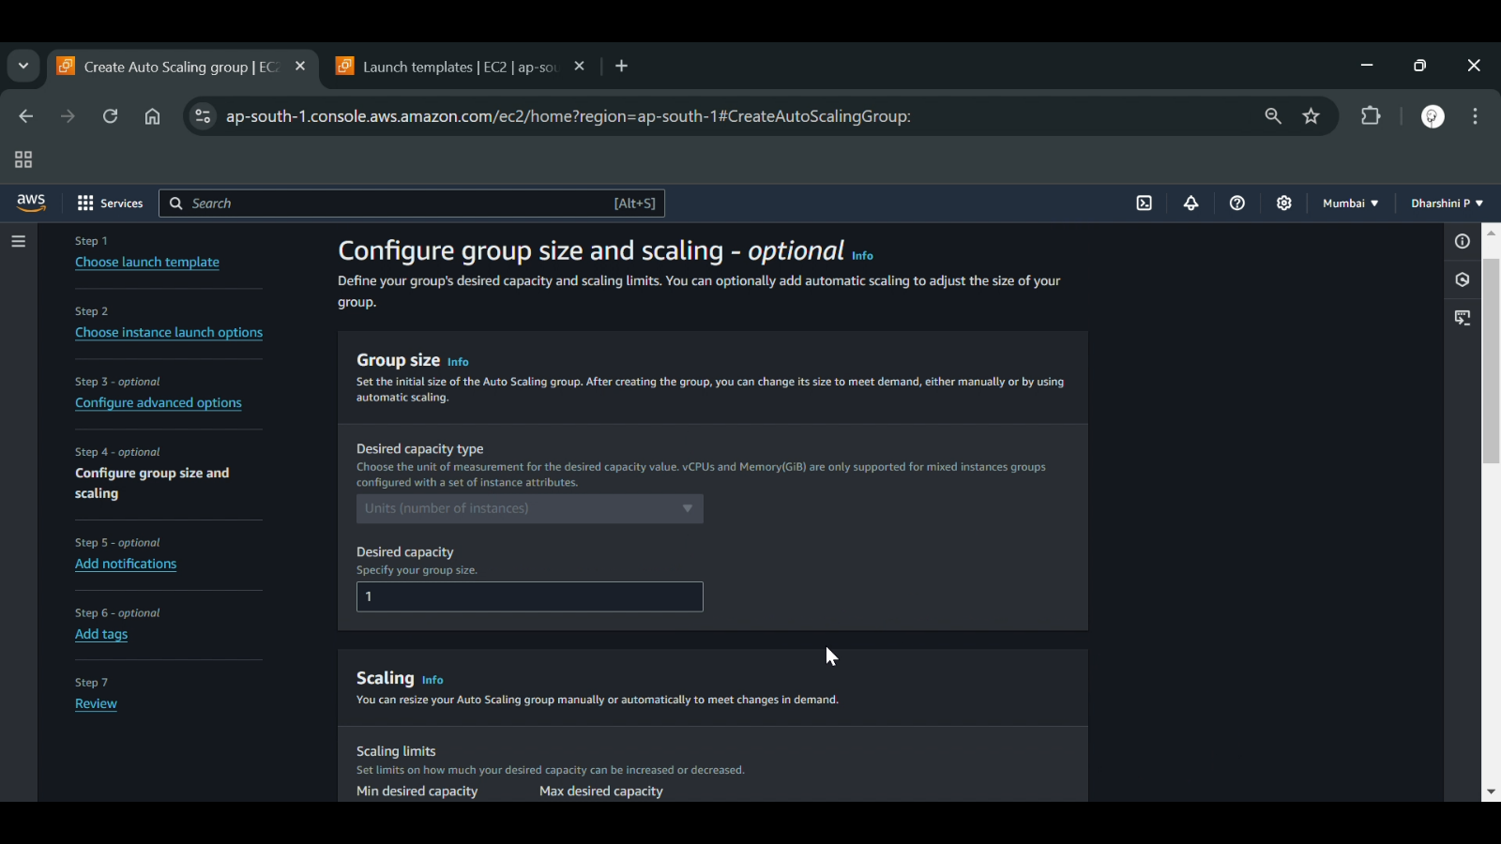

**Step 4:**

**Set Up Load Balancer (Optional but Recommended)**

* Integrate a load balancer (e.g., AWS Elastic Load Balancer, Azure Load Balancer).
* Distribute traffic evenly across instances.

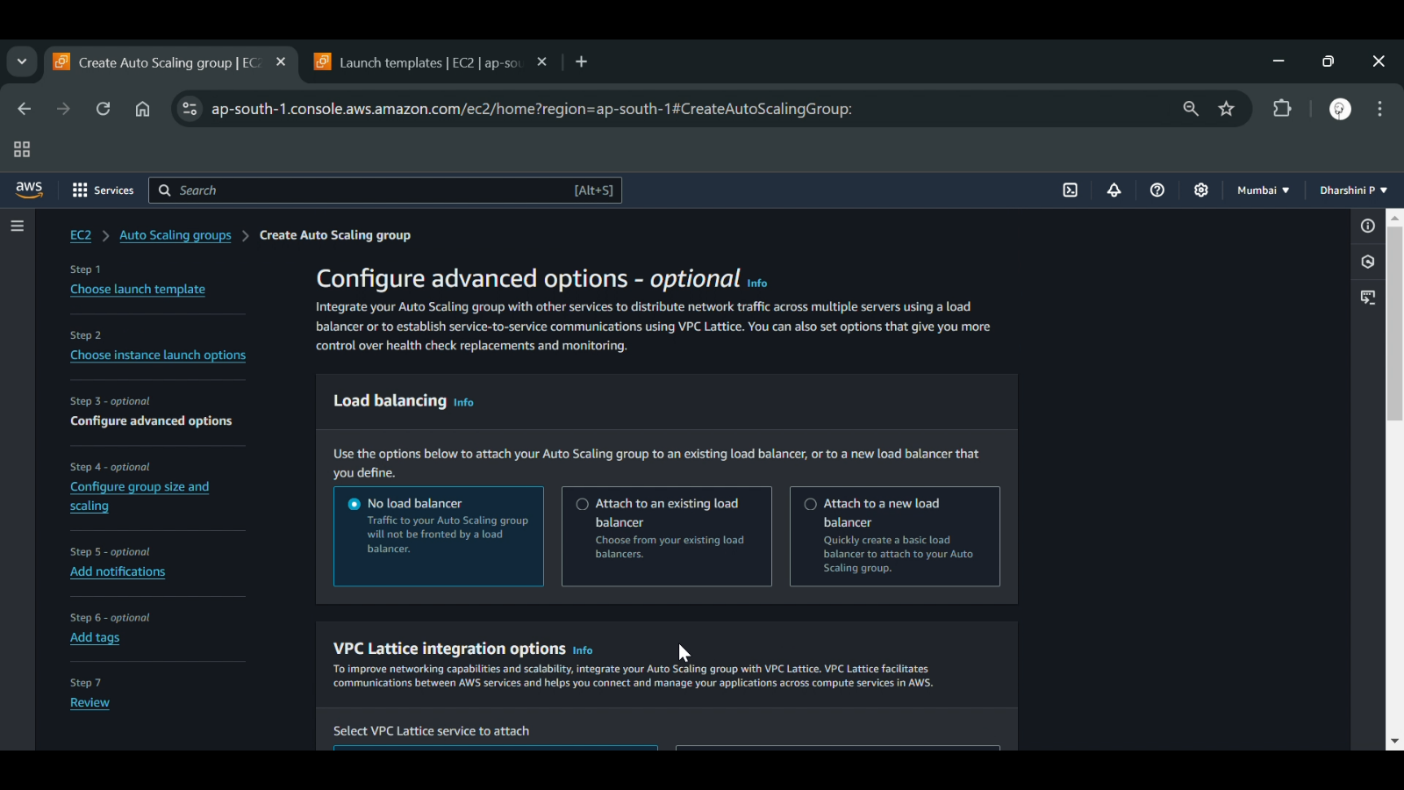

**Step 5:**

**Monitor and Optimize**

* Use monitoring tools (AWS CloudWatch, Azure Monitor, Google Cloud Operations Suite) to track performance.
* Adjust scaling rules if necessary based on observed workload patterns.

**Expected Outcome:**

**By completing this POC, you will:**

* Efficient resource utilization with automated scaling.
* Improved application performance during traffic spikes.
* Cost savings by eliminating idle resources.
* Enhanced system availability and fault tolerance